Setting up the autonomous bot with ROS2
Table of Contents
Installation: 2
General introduction: 5
Packages: 6
ROS2 bridge: 6
Slam toolbox: This ROS2 package allows us to create a 2D map of the environment using SLAM and data from a 2D LIDAR. 6
Navigation 2: 6
🔹 Nodes 7
🔹 Topics 7
🔹 Messages 8
🔹 Services & Actions 8
🔹 Workspaces 8
The Virtual-mechanical linkages in ROS2: The TF Tree 9
1. What it is 9
2. Key Frames 9
3. How It Works 9
4. Why It’s Important 10
5. Dynamic vs Static Transforms 10
6. Tools 10
Universal / Conventional ROS 2 Topics 11
🔹 /odom (Odometry) 11
🔹 /map 11
🔹 /tf and /tf_static 12
🔹 /scan 12
🔹 /cmd_vel 12
🗺 Standard Topic Flow (Big Picture) 13

Installation:
In my ROS2 setup, using a bot as muscles, RPi 5 as bot’s brain with navigation equipment (sensors) connected to it, a supervising PC (development, supervision).
ROS2 distribution selected: ROS2 Jazzy Jalisco for Ubuntu 24.04.X, source install:
https://docs.ros.org/en/jazzy/Installation/Alternatives/Ubuntu-Development-Setup.html
(newest at the time) RPi average compile & install time 20 minutes.
Install ROS2

sudo apt install software-properties-common
sudo add-apt-repository universe
sudo apt update && sudo apt install curl -y

export ROS_APT_SOURCE_VERSION=$(curl -s https://api.github.com/repos/ros-infrastructure/ros-apt-source/releases/latest | grep -F "tag_name" | awk -F\" '{print $4}')

curl -L -o /tmp/ros2-apt-source.deb https://github.com/ros-infrastructure/ros-apt-source/releases/download/${ROS_APT_SOURCE_VERSION}/ros2-apt-source_${ROS_APT_SOURCE_VERSION}.$(. /etc/os-release && echo ${UBUNTU_CODENAME:-${VERSION_CODENAME}})_all.deb

sudo dpkg -i /tmp/ros2-apt-source.deb
sudo apt update
sudo apt install python3-colcon-common-extensions

For minimal install (desktop-less):
sudo apt install ros-jazzy-ros-base
For default install (desktop):
sudo apt install ros-jazzy-desktop

Setup environment:
echo "source /opt/ros/jazzy/setup.bash" >> ~/.bashrc
source ~/.bashrc
Standard workspace:
mkdir -p ~/ros2_ws/src
cd ~/ros2_ws
colcon build

Colcon, only executed in the mentioned path location, is the project builder. After each project file modification, it’s encouraged to run it in order to compile/ build the project files.

Configure PC & RPi to same LAN:
export ROS_DOMAIN_ID=10 #any ID, I took 10, must match both devices
export RMW_IMPLEMENTATION=rmw_fastrtps_cpp
export ROS_LOCALHOST_ONLY=0

The DDS middleware discovery service will use automatically ports 7400–7600.
Restart nodes and re-source workspace:
source /opt/ros/<your_ros2_distro>/setup.bash
source install/setup.bash

Test ROS same LAN communication:
This is only available if the desktop install was used, otherwise they can be installed in addition:
sudo apt install ros-jazzy-demo-nodes-cpp ros-jazzy-demo-nodes-py

Running the test:
On PC or RPi:
. ~/ros2_jazzy/install/local_setup.bash
ros2 run demo_nodes_cpp talker

On opposite device:
. ~/ros2_jazzy/install/local_setup.bash
ros2 run demo_nodes_py listener

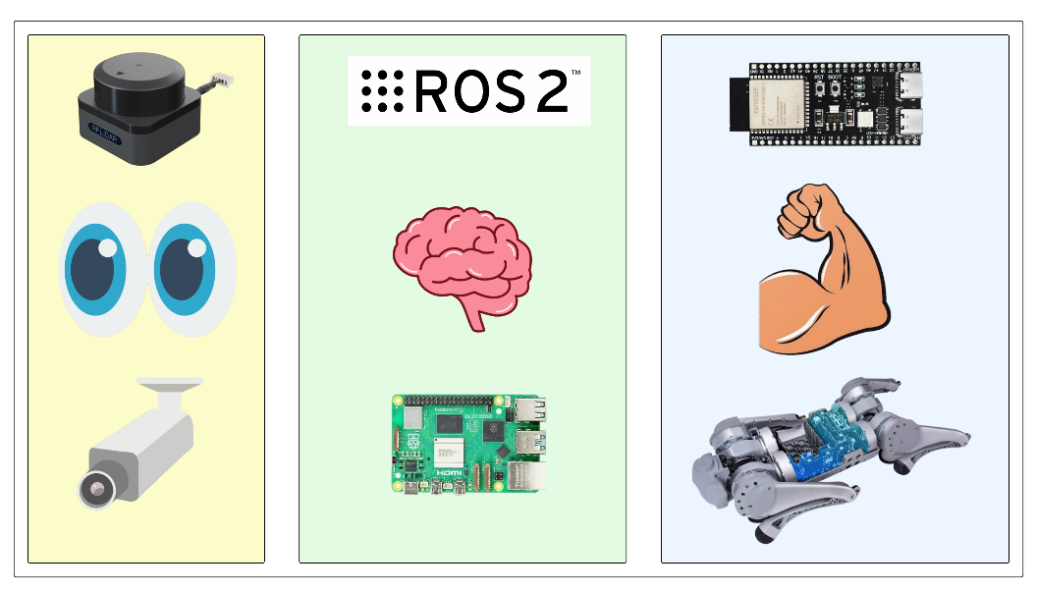

The LiDAR
Install as instructed in the standard ROS2 workspace:
https://github.com/Slamtec/sllidar_ros2?tab=readme-ov-file#compile--install-sllidar_ros2-package

Unitree Go1 ROS -> ROS2 bridge:
https://index.ros.org/p/unitree_ros/

Slam toolbox:
https://github.com/SteveMacenski/slam_toolbox?tab=readme-ov-file#install

Navigation 2:
https://docs.nav2.org/development_guides/build_docs/index.html

General introduction:
The basics of how ROS works:
ROS2 devices use the mentioned DDS service to enable it’s publish/ subscribe mechanism (similar to mqtt). It handles discovery and message transport using multicast & unicast communication.
A project is usually stored under the form of a ROS package: in this package there can be any types of files needed for the robot’s function. Usually packages encompass configurations, launchers, definitions and scripts for operation modes and others.
These scripts often called nodes and only certain required ones are activated during the operation of the robot, it is common for packages to contain numerous nodes. Big assets like slam toolbox, or navigation 2, premade configurations or the programs to run specific hardware use their own packages to remain organized and modular for development.
Given this, it’s not uncommon for robots to have multiple packages installed, the logistical issue this poses is that each node has to be called separately from each needed package manually. This in term is solved with scripted launchers.

Packages:

ROS2 bridge:
The dog model can be interfaced with using either ROS 1, MQTT (limited) or UDP messages. Logically we want to use the existing ROS infrastructure for the communication.
Since both ROS revisions use different protocols for communication a package for bridging the two is necessary. The one used here is specific for this robot and not official, yet it exposes the same ROS topics as the robot.
Using this bridge, we can send movement, LED and audio commands all corresponding to the ROS 2 standard, in return we get the data of each of the robot’s sensors like ultrasonic, position encoders, imu, cameras, battery state and possibly microphone.

Slam toolbox:
This ROS2 package allows us to create a 2D map of the environment using SLAM and data from a 2D LIDAR.

Navigation 2:
Nav 2 allows the robot to load a saved map, localize itself and navigate on the territory. This package is built officially for our ROS2 version and thus the installation is default.
For it to work, it requires a pre-made map of the territory and a planned path to follow. The rest is handled by it, like the obstacle avoidance, position estimation and checkpoint following.
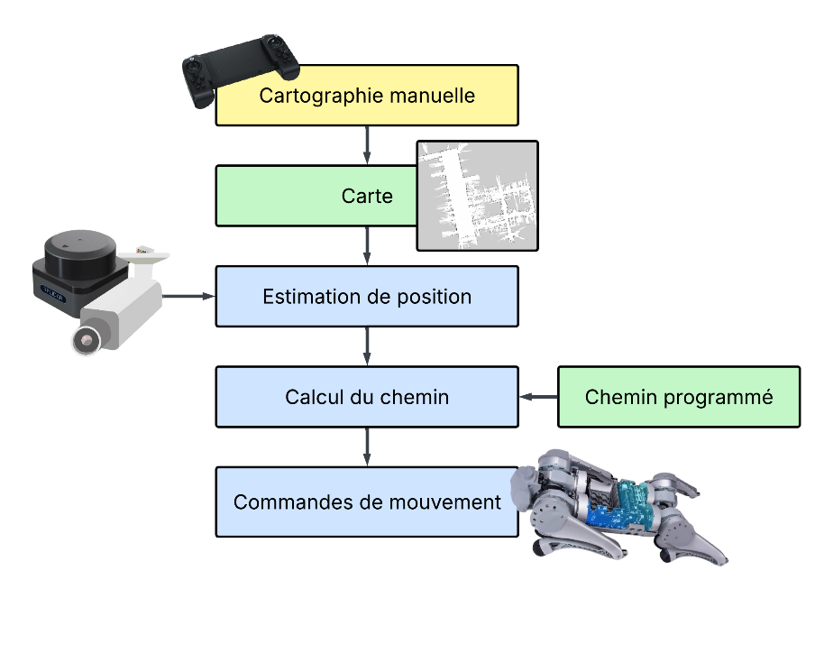
In yellow is the only external manual operation required, but it could also be automated. In green are the files/ configurations we define for the robot’s territory.
And in blue is the logic loop that Navigation 2 is repeating to achieve autonomous navigation.

What is ROS ?
- A middleware, not an OS, not a simulator but it runs on top of Linux.
- Provides:
  - Communication (nodes, topics, services, actions).
  - Standard interfaces (msgs like Odometry, LaserScan).
  - Tools (RViz, rosbag, colcon).
Core Concepts.

🔹 Nodes
- Small processes that do one thing (e.g., publish sensor data, control motors).
- Written in Python or C++.

🔹 Topics
- Channels where nodes send/receive data.
- Example: /scan carries laser scans.
- Asynchronous, many-to-many communication.

🔹 Messages
- Typed data sent on topics.
- Example: /odom uses nav_msgs/msg/Odometry.

🔹 Services & Actions
- Request/response (services) and long-running tasks with feedback (actions).

🔹 Workspaces
Where you build and organize your own packages with colcon.

Visualization, on device or supervision
- Rviz2 included app
- Shows how topics and TF frames are used

Universal Topics + TF
- Sensors publish to topics (/scan, /odom).
- SLAM publishes a map (/map).
- TF connects frames (map → odom → base_link).

The Virtual-mechanical linkages in ROS2: The TF Tree

1. What it is
- A dynamic tree of coordinate frames that describe how every part of the robot (and its world) relates in space.
- Built from transforms broadcast by nodes, aggregated into a single tree by the tf2 system.
- Every frame has 3D coordinates.

2. Key Frames
- map → Global, fixed frame of the world (from SLAM or GPS).
- odom → Local continuous frame (tracks robot drift-free over short time).
- base_link → Robot’s body frame (origin usually at center of chassis).
- sensor_frame → Each sensor has its own frame (e.g., camera_link, lidar_link).
- wheel_link, gripper_link, etc. → Subcomponents.

3. How It Works
- Each node publishes its transforms:
  - SLAM publishes map → odom.
  - Odometry source publishes odom → base_link.
  - URDF / robot_state_publisher publishes static frames (base_link → camera_link, etc.).
- Together, these make a chain from map → odom → base_link → sensors.

4. Why It’s Important
- Every ROS 2 system (navigation, perception, control) needs to transform between frames.
- Example:
  - A LiDAR (laser_scan) can be transformed into the robot’s base frame (base_link).
  - A global goal in map can be converted into odom or base_link.
- Without a consistent TF tree, data from different sensors cannot be fused or visualized correctly.

5. Dynamic vs Static Transforms
- Dynamic (/tf): changes over time (robot moving, arm joints moving).
- Static (/tf_static): fixed transforms (e.g., camera rigidly attached to chassis).

6. Tools
- ros2 run tf2_tools view_frames → generates a PDF of the TF tree.
- RViz can display the frames live.

Universal / Conventional ROS 2 Topics

🔹 /odom (Odometry)
- Message type: nav_msgs/msg/Odometry
- Publisher: Typically the robot’s localization source (wheel encoders, visual odometry, SLAM backend).
- Consumer:
  - Navigation stack (Nav2) uses it for robot pose estimation.
  - RViz can visualize trajectory.
- Contains:
  - Pose (x, y, z, orientation).
  - Twist (linear & angular velocities).
  - Reference frame: usually odom.

🔹 /map
- Message type: nav_msgs/msg/OccupancyGrid
- Publisher: Mapping or SLAM system (e.g., slam_toolbox, cartographer).
- Consumer:
  - Navigation (path planning).
  - Visualization (RViz shows the grid map).
- Contains:
  - A 2D grid with free/occupied/unknown cells.
  - Metadata: resolution, origin, dimensions.
- Reference frame: map.

🔹 /tf and /tf_static
- Message type: tf2_msgs/msg/TFMessage
- Publisher: Many nodes publish transforms for their frames.
- Consumer: Everybody (RViz, Nav2, perception nodes, etc.).
- Contains:
  - Coordinate frame transforms (tree structure: map → odom → base_link → sensor_frame).
- /tf = dynamic transforms (robot moving).
- /tf_static = static transforms (e.g., lidar mounted rigidly on robot).

🔹 /scan
- Message type: sensor_msgs/msg/LaserScan
- Publisher: 2D LiDAR driver.
- Consumer:
  - SLAM (to build the /map).
  - Obstacle detection & navigation.

🔹 /cmd_vel
- Message type: geometry_msgs/msg/Twist
- Publisher: Planner or teleop node.
- Consumer: Robot base controller.
- Contains:
  - Linear velocity (x, y).
  - Angular velocity (z).
- Acts as the universal velocity command interface.

🗺 Standard Topic Flow (Big Picture)
- Sensors → publish /odom, /scan, /camera/*, /pointcloud.
- Localization / SLAM → consumes /scan + /odom, publishes /map.
- Transforms (/tf) → glue all frames together.
- Planner (Nav2) → consumes /map + /odom, publishes /cmd_vel.
- Robot base → executes /cmd_vel, moves robot.

Frequent sources:
Backdoors GO1: https://www.youtube.com/watch?v=lAuvVsZrVMA
nav2:
https://docs.nav2.org/getting_started/index.html https://docs.nav2.org/plugins/index.html https://docs.nav2.org/setup_guides/sensors/mapping_localization.html https://docs.nav2.org/tutorials/docs/navigation2_with_slam.html
costmap: https://docs.nav2.org/plugin_tutorials/docs/writing_new_costmap2d_plugin.html
amcl: https://docs.nav2.org/configuration/packages/configuring-amcl.html
ros2 inst: https://docs.ros.org/en/jazzy/Installation/Alternatives/Ubuntu-Development-Setup.html
gps: https://docs.ros.org/en/api/robot_localization/html/integrating_gps.html
slambox: https://github.com/SteveMacenski/slam_toolbox?tab=readme-ov-file
Ros Go1: https://docs.trossenrobotics.com/unitree_go1_docs/getting_started/ros.html
slidar:
https://github.com/Slamtec/sllidar_ros2
https://github.com/slamtec/rplidar_ros

